Name:________________________________________________________________________
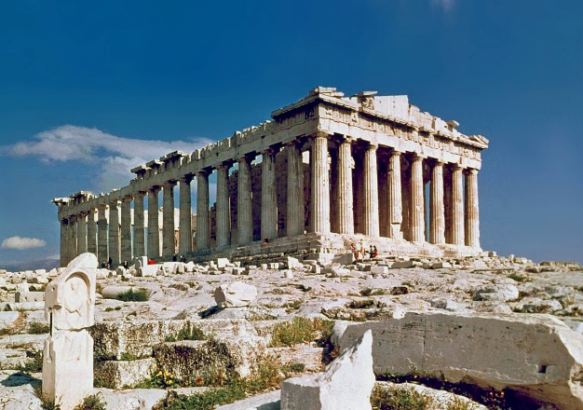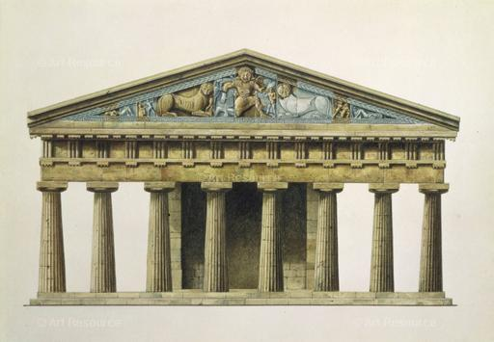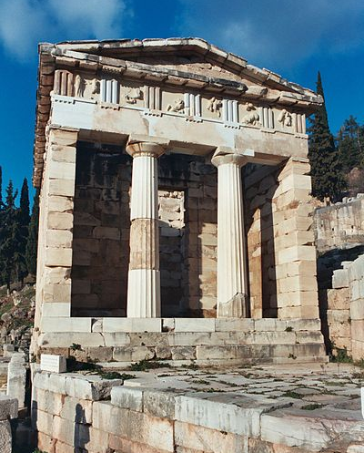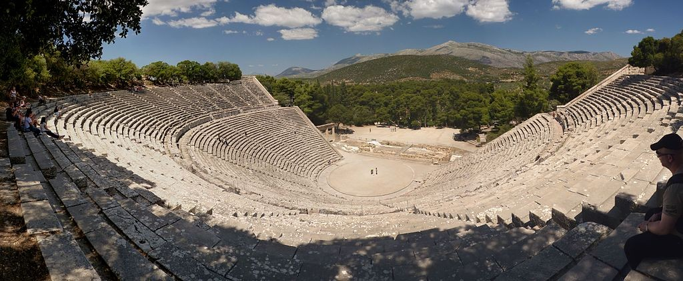

Instructions
- Choose an event, a god/goddess or some other aspect of Ancient Greece, and write it below:

My monument will be dedicated to ____________________________________________________________________________________
- Sketch a monument design dedicated to whatever you chose on the back of this paper – use abstraction to think about how your architecture relates to your topic!

- Create your monument in 3D using TinkerCad: tinkercad.com

- In a Google Doc, paste the link to to your TinkerCad design and write at least two paragraphs to accompany your design describing how you came up with the idea and how your monument relates to your topic

Sketch your monument design here

Rubric
 | Doesn’t meet expectations [0] | Approaching expectations [1-4] | Meets expectations [5-8] | Exceeds expectations [9-10]
Sketch | Sketch not completed | Sketch is not understandable  Sketch doesn’t relate to 3D model | Sketch is understandable  Sketch was used while creating 3D model | Sketch is clear and well thought out  Sketch closely aligns with 3D model
3D monument | 3D monument not completed | 3D monument uses fewer than five elements  3D monument does not reflect Ancient Greek style | 3D monument uses between five and ten elements  3D monument could be seen as using Ancient Greek style | 3D monument uses more than ten elements  3D monument is a clear reflection of Ancient Greek style
Written explanation | Written explanation not completed | Written explanation shorter than two full paragraphs  Written explanation does not connect chosen topic with monument | Written explanation is at least two paragraphs  Written explanation makes some attempt to connect chosen topic with monument | Written explanation is at least two well-structured paragraphs  Written explanation clearly connects chosen topic with monument
Creativity and effort | Total lack of creativity or effort | Some creativity is seen across all elements  Some components show signs of effort | Creativity is seen across all elements  All elements show signs of effort | All elements are exceptionally creative and clearly took a great deal of effort

Score : _____ / 40

